**Exploring Decarbonization of a Steel Reheating Furnace using Simulations of Natural Gas/Hydrogen Fuel Blending**

Muhammad Basil Lutfi1, Nicholas J. Walla1, Abhishek Kolakotla1, Kurt Johnson2, David Schalles3, Chenn Q. Zhou1

1Purdue University Northwest, Hammond, IN. czhou@pnw.edu

2Cleveland-Cliffs Burns Harbor, Burns Harbor, IN.

3Bloom Engineering Company, Charleroi, PA.

**Keywords:** combustion modelling, decarbonization, hydrogen fuel blending, reheating furnace, regenerative burners

**ABSTRACT**

The steel industry is a cornerstone of U.S. manufacturing, infrastructure, and defense, supplying one of the most vital materials. The slab reheating furnace, a crucial process in steelmaking, is highly energy-intensive and produces substantial CO2 emissions due to natural gas combustion. Computational fluid dynamics (CFD) simulation has emerged as a powerful research and development tool to optimize furnace performance, enhance energy efficiency and productivity, and investigate alternative fuels like hydrogen to reduce CO2 emissions. Currently, in the real-world furnaces using natural gas, pre-heated air is used for combustion, whereas the natural gas inlets are kept at room temperature. But while transitioning to hydrogen combustion, this may not be required. This paper showcases state-of-the-art CFD simulations of industry-scale reheating furnaces that use methane-hydrogen fuel blends with varying air inlet temperatures. Using a hydrogen fuel blend can potentially lead to significant reductions in CO2 emissions. Examples from the PNW Center for Innovation through Visualization and Simulation (CIVS) and the Steel Manufacturing Simulation and Visualization Consortium (SMSVC) will be included.

**INTRODUCTION**

The steel industry depends on the reheating furnace (RF), a vital and energy-intensive process, to heat slabs before they are processed in the rolling machine. The significant energy consumption of this process contributes to the steel industry’s high carbon emissions [1]. Thus, it is crucial to explore alternative fuels to reduce natural gas consumption and emissions [2] from combustion-driven processes like reheating furnaces. It is important to assess the impact of various H2/NG mixtures in commercial furnaces currently fueled by natural gas. Computational fluid dynamics (CFD) has emerged as a powerful tool for research and development. Once validated, CFD models can simulate full-scale furnace operations under various conditions, offering a significant advantage over experimental setups [3].

Steel manufacturing is one of the highest energy consuming industries in the world, with almost a 5% of the world’s total energy [4]. Steel production is currently undergoing an active evolution towards minimized carbon emissions to meet net-zero carbon emission goals or similar “green steel” plans. One major focus area in these efforts is the replacement of hydrocarbon-fired processes with hydrogen as a carbon-free alternative [5]. However, conversion of reheating furnace operations from natural gas to hydrogen fuel is not a simple task. Hydrogen not only combusts differently from natural gas (most notably with higher flame temperatures and flame speeds), but the current hydrogen economy also makes wholesale conversion to hydrogen a costly and difficult effort [6]. Better understanding on the impacts of hydrogen usage in a large industrial process such as a steel reheating furnace is thus an essential part of planning for a green steel future. As inside the furnace, the flow field of the hot gas has significant influence on heating slabs [7] to develop an understanding of optimized combustion.

Although major design changes, such as regenerative burners which utilize highly pre-heated air, can improve process efficiency[8], T. Ishiguro et al [9] states pre-heated air is a key technology for reducing emissions, Furthermore, Ishiguro notes that the use of high-temperature combustion air can substantially improve the thermal field uniformity within furnaces. Kashir Et al states that pre-heating of air also improves flame stability with respect to the dilution process, and more encourages more-stable flames [10]. W.B. Kim et al conducted a study on highly pre-heated air, where they mention preheating of air causing increased flame propagation, amongst other phenomena. [11]

**CFD MODEL AND METHODOLOGY**

The objective of this paper is to determine whether preheating the air improves furnace operations when using hydrogen blends in the furnace. By comparing the performance of the furnace under these different conditions- air preheated to 640K, 450K, and ambient temperature (303K) the study aims to provide insights into the benefits and impacts of air preheating. In the 100% natural gas case, pre-heated air is used to aid combustion, enhancing the efficiency and effectiveness of the process. However, when transitioning to a 50/50 blend with hydrogen or a 100% hydrogen blend, this pre-heating of air may not be necessary. This is because hydrogen produces significantly more heat than a natural gas flame, being approximately 263 kelvins hotter. This was tested using a single burner case, comparing 100% natural gas to 100% hydrogen. The results suggested that the higher temperature of the hydrogen flame might eliminate the need for preheating the air. To evaluate the impact of air preheating on combustion efficiency and furnace performance, three different cases were run with the 100% H2 case and the 50/50 H2/NG blend. The first case, serving as the baseline, uses preheated air at 640K and matches the conditions of furnace operation with 100% natural gas scenario. This baseline provides a reference point for comparison with other scenarios. The second case examined the effects of using air heated to 450K, representing a moderate reduction in preheat temperature. This scenario aimed to explore how a decrease in air preheat temperature would affect the combustion process and overall furnace efficiency when using a hydrogen blend. The third case simulated the use of air at approximately environmental temperatures, around 303K. This "cooler" case investigated the potential of eliminating the preheating step, relying solely on ambient air temperature.

The comprehensive furnace simulation models turbulent fluid flow and combustion based on the principles of conservation of mass, momentum, and energy. The SIMPLE algorithm is utilized to solve the pressure-velocity coupling equations, and the Second Order Upwind scheme is applied to the momentum and energy equations. In this steady-state study, the reheat furnace simulation is governed by integrating the Navier-Stokes and energy equations throughout the furnace domain. The species transport model is used to monitor the concentration and distribution of combustion species within the furnace. A coupled solver, along with the k-epsilon turbulent model, is employed to handle turbulent reactions. For accurate chemical reaction modeling, the integrated finite-rate/Eddy dissipation model is applied. The flow field inside the furnace, with Reynolds averaged terms, can be effectively solved using the k-ɛ model. The realizable k-ɛ model is used to simulate turbulence, featuring an alternative formulation for turbulent viscosity and a modified transport equation for the dissipation rate, derived from the exact equation for the transport of mean-square vorticity fluctuations.

We currently utilize a 3-step mechanism for the combustion process within the furnace. This mechanism involves two steps dedicated to the decomposition of methane (CH4) and one step focused on the combustion of hydrogen (H2). The first two steps involve breaking down methane (CH4) into simpler components through a series of chemical reactions. These reactions ensure that the methane is fully decomposed into intermediate species and products that can participate in further reactions. The third reaction is concerned with the combustion of hydrogen (H2), which is a product of the methane decomposition process. In this step, hydrogen reacts with oxygen to produce water and release energy. This combustion step is crucial for completing the overall combustion process and maximizing energy output into the furnace. By using this 3-step mechanism, we can efficiently manage the combustion process within the furnace, ensuring optimal performance and energy utilization.

|  |  |  |
| --- | --- | --- |
| **Reactions** | **Pre-exponential Factor (A)** *[1/s]* | **Activation Energy (E)**  *[J/mol]* |
| 1. CH4 + 3/2 O2 → CO + 2 H2O | 5.012 x 1011 | 2.0 x 108 |
| 1. CO + 1/2 O2 → CO2 | 2.239 x 1012 | 1.7 x 108 |
| 1. H2 + 1/2 O2 → H2O | 9.87 x 108 | 3.1 x 107 |

Table 1. 3 Step Reaction for Methane and Hydrogen

The baseline case employs 100% natural gas (NG) for the combustion process, with the natural gas composition consisting of approximately 91% methane (CH4). To determine the amount of hydrogen (H2) required for the furnace, particularly for a 50/50 blend scenario, we first calculated the energy delivered by the 100% natural gas to the furnace. Our methodology fixes the heat input of the fuel across all cases, changing the composition and flow rates to accommodate. The baseline operating conditions represent roughly 150MW of heat delivered to the furnace via the sum total of the burners. Using the lower heating value (LHV) of the fuels, we can estimate the necessary fuel input required to deliver specific percentages of total heat input. For example, the 50/50 blend has 50% of the energy coming from natural gas and 50% coming from hydrogen. As we are fixing the heat input, the total mass flow of air and fuel decreases as the percentage of fuel energy from hydrogen increases due to a combination of hydrogen’s higher LHV compared to natural gas and its lower density.

**SIMULATION CONDITIONS**

**Computational Domain**

A computational model of Cleveland-Cliffs’ Indiana Harbor reheat furnace has been developed to determine flow conditions during steady-state operation using CFD. The walking beam furnace is 53.8 meters long, 11.3 meters wide, and 3.92 meters high. ANSYS Workbench was used to create a mesh of the entire furnace domain for simulation purposes. The furnace is divided into five zones through which slabs pass: preheat, heating zones 1 and 2, intermediate, and soaking zones, as illustrated in Figure 1. Two flue gas outlets are located near the charge door in the preheat zone, with the slab discharge door positioned at the end of the soaking zone. The preheat zone contains 12 burners, heating zones 1 and 2 have 12 and 16 burners each, respectively. The intermediate zone features 8 burners in the top section and 10 in the bottom. The soak zone contains 36 downward-facing burners and 11 burners facing the longitudinal axis of the furnace.

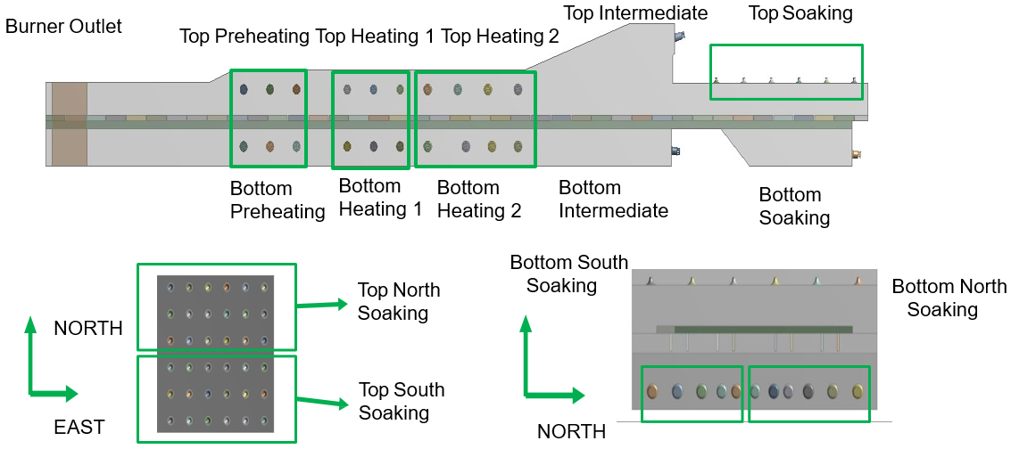

**Figure 1. Overview of furnace geometry**

**Boundary Conditions**

The boundary conditions in the furnace are specified to ensure an accurate and realistic simulation of its operation. The walls utilize a no-slip condition, which means that the fluid velocity at the surface of the walls is zero, effectively preventing any relative motion between the wall and the fluid. This condition is crucial for accurately modeling the interaction between the fluid and the furnace walls. A constant gauge pressure of 20 Pa is applied at the stacks, through which the exhaust gases exit to the recuperator. This pressure condition ensures a consistent flow of exhaust gases out of the furnace, maintaining a stable internal environment. The furnace walls are assumed to be adiabatic, meaning there is no heat transfer to/from the walls and an external environment. The wall material is also given a thermal emissivity value of 0.75. This property is important for accurately modeling radiative heat transfer within the furnace. The burners play a critical role in the combustion process by injecting fuel and preheated air into the furnace. The air temperatures used for these injections are 303K, 450K, and 640K, with the latter being the baseline currently used in real-world furnace operations. By varying the air temperature, the simulation can evaluate the impact of different preheat levels on the furnace's performance. Both natural gas and hydrogen are maintained at a temperature of 303K when injected into the furnace. This consistent fuel temperature helps ensure that the combustion dynamics and energy output are accurately assessed, providing a clear understanding of how each fuel type performs under the given conditions.

Table 2. Fuel input rates (Kg/s)

|  |  |  |  |  |
| --- | --- | --- | --- | --- |
| ***Fuel Per Zone*** *[kg/s]* | | | | |
| ***Case*** | ***Preheat Zone*** | ***Heating Zone*** | ***Intermediate Zone*** | ***Soak Zone*** |
| ***50% CH4*** | 0.0706 | 1.373 | 0.416 | 0.201 |
| ***100% H2*** | 0.0420 | 0.808 | 0.245 | 0.119 |

Table 3. Species overview

|  |  |  |  |
| --- | --- | --- | --- |
| Mass Fractions of Species in Fuel (%) | | | |
| ***Species*** | ***Air*** | ***50:50 blend*** | ***Hydrogen*** |
| ***O2*** | *21* | *-* | *-* |
| ***N2*** | 79 | 4.6 | - |
| ***CO2*** | - | 1.6 | - |
| ***CH4*** | - | 64 | - |
| ***H2*** | - | 29 | 100 |

**RESULTS AND DISCUSSIONS**

This analysis aims to evaluate the results comprehensively and identify the respective trends across different ar inlet temperatures, with the primary focus being on combustion-related parameters. We will investigate flame temperatures to understand how different fuel compositions influence the intensity and efficiency of combustion. Additionally, flame lengths will be assessed, as they provide insights into the stability and spread of the flame within the furnace.

Furthermore, flue gas analysis will be conducted to assess emissions and combustion efficiency. Parameters such as gas composition, temperature will be examined to determine the environmental impact and operational efficiency of each case. By synthesizing data from these key parameters, we aim to draw meaningful conclusions about the combustion with different air inlet temperature conditions

For our flame shape mapping, our one-step combustion process for hydrogen presents a limitation in modeling flame shapes using species concentration data. To address this, we utilize a temperature boundary clip set at 2000 Kelvin to map the flame. This approach allows us to approximate the flame structure and characteristics effectively. By using this temperature threshold, we can delineate the high-temperature regions associated with the flame, providing a practical method for visualizing and analyzing the flame's shape and behavior in the absence of detailed species concentration data.

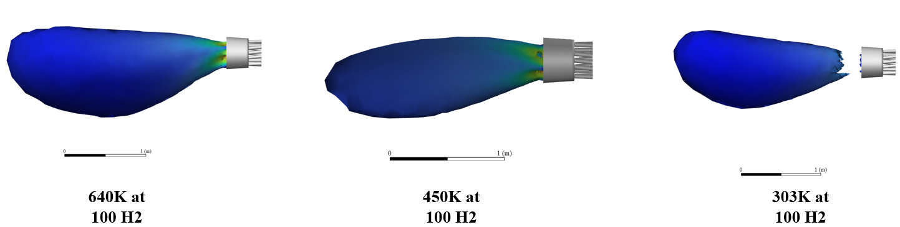

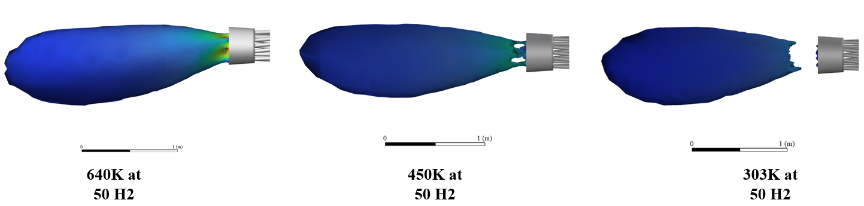



Fig 2. Flame Shapes in Heating Zone

The velocity contours above were overlaid onto an iso-clip corresponding to 2000 Kelvin in each experimental condition to meticulously examine the morphology and dimensions of the flames. As anticipated, the flame at 640 Kelvin exhibited the most expansive dimensions. An intriguing observation emerged in both cases at 303 Kelvin, revealing a significant delay in the combustion process. This phenomenon suggests that combustion initiation is significantly influenced by the temperature of the incoming air, which enters at ambient conditions. Subsequently, combustion progresses distant from the inlet due to above. This can also be slightly viewed in the 450K cases, where there is a gap in between the plume and the air inlet. To be noted, not only is the flame length the highest for 640K, but overall size was the largest aswell.

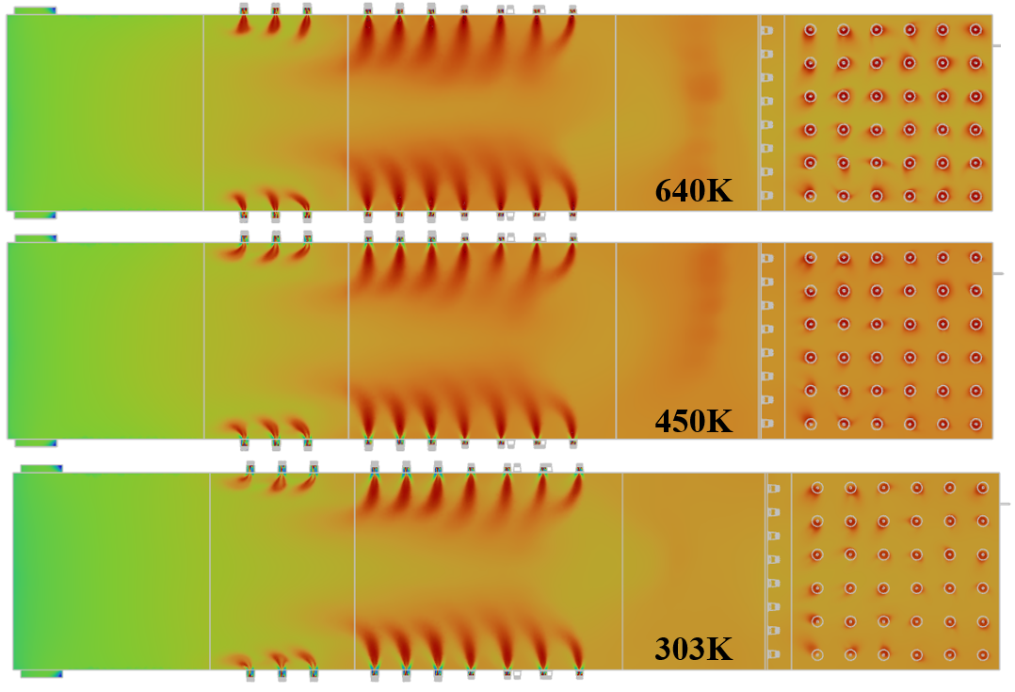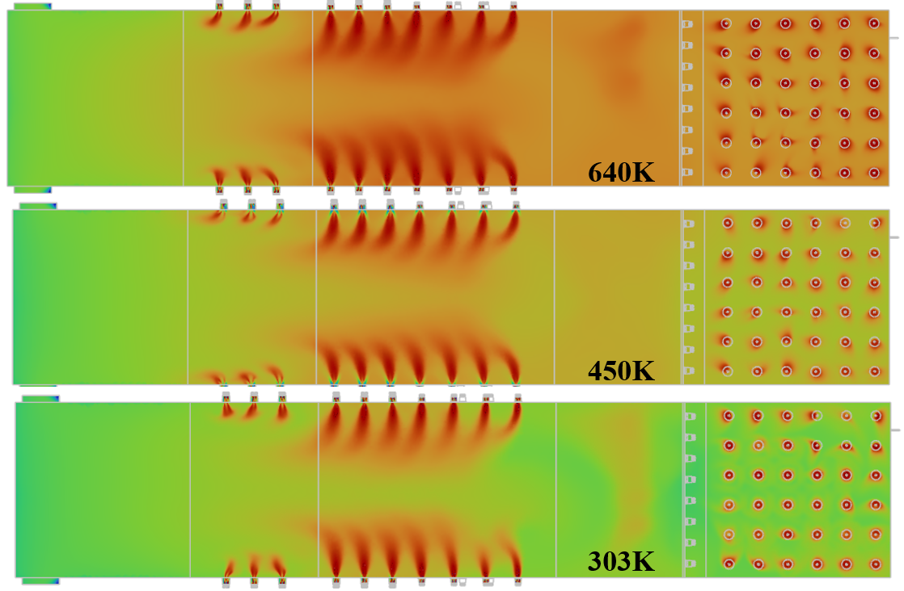

  
Figure 3. Contours of temperature through the furnace for 100% H2 (left) and 50/50 blend (right)

The contours in Figure 3 depict temperature contours of the entire furnace, with an upper boundary set at 2300 Kelvin. The average temperatures within the furnace show a declining trend with the reduction of air inlet temperatures. However, it is noteworthy that the flame temperatures remain nearly identical across varying air inlet temperatures. This indicates that the reduction in air inlet temperature primarily affects the thermal efficiency and energy dynamics of the furnace rather than the combustion efficiency itself.

The intermediate zone of the furnace shows the greatest difference in temperature response to changes in combustion air temperature. As the air inlet temperatures decreases, the overall energy delivered to the furnace decreases aswell, a trend that becomes distinctly evident when comparing the temperature variations between the areas downstream and upstream of the intermediate zone.

The average fluid temperatures in the 100% hydrogen combustion case are consistently higher throughout the furnace compared to the 50/50 hydrogen-natural gas blend. This disparity can be attributed to hydrogen's higher combustion temperature. As noted by the figures, the case using 100% hydrogen utilizing non-preheated air exhibits an average temperature profile nearly identical to that of the 50/50 blend case utilizing fully preheated air at 640 Kelvin. This trend shows us the significant impact of hydrogen's higher combustion characteristics, the elevated temperatures associated with pure hydrogen combustion enhance the overall thermal efficiency, despite the lower air inlet temperatures, thereby indicating a possible need for not needing preheated air when using a hydrogen case.

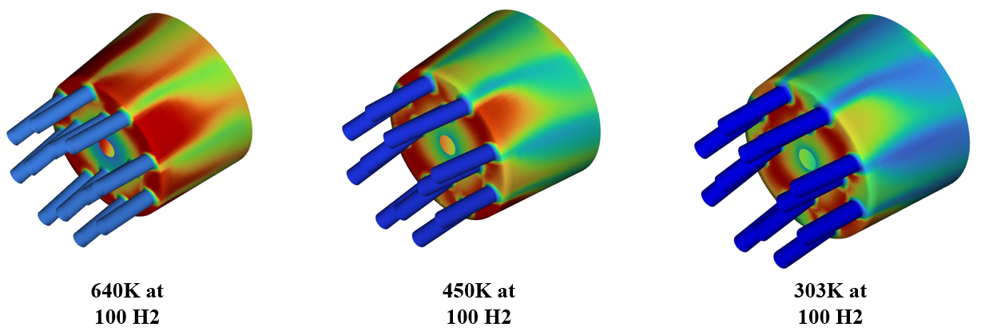

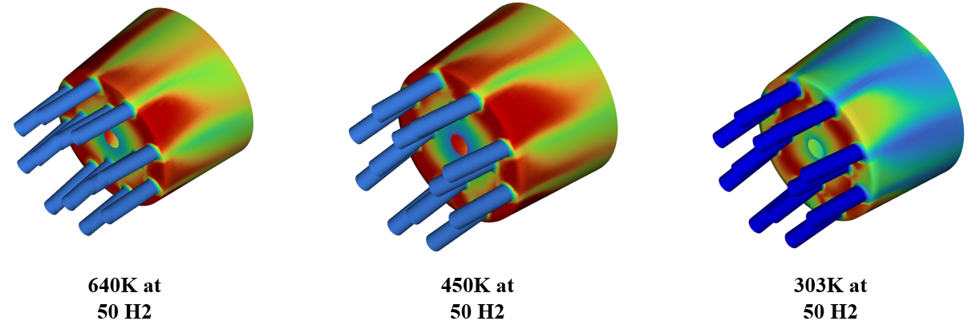



Figure 4. Wall-adjacent temperatures for burners

The comparison of wall-adjacent temperatures of burners located in the soak zone of the reheat furnace provides insightful data on how varying air inlet temperatures influences near-burner temperatures. Figure 4 shows the wall-adjacent temperatures of the burners in the second heating zone, showing the large differences near the burner.

As was shown in Figure 2, the isosurfaces of 2000K are farther from the burner for the 303K air inlet case. This, combined with the burner adjacent temperatures of Figure 4, showcase a displacement of the hottest regions of the flame farther away from the wall of the furnace.

Furthermore, flue gas analysis was conducted to assess emissions and combustion efficiency. Parameters such as gas composition, temperature will be examined to determine the environmental impact and operational efficiency of each case. By synthesizing data from these key parameters, we aim to draw meaningful conclusions about the combustion with different air inlet temperature conditions

Table 4. Flue Gas and Bulk Furnace Temperatures

|  |  |  |  |  |
| --- | --- | --- | --- | --- |
| 100% Hydrogen as Fuel | | | | |
| Air Inlet Temperature (K) | | Flue Output Temperature (K) | | Average Temperature of Furnace Domain (K) |
| 640 | | 1139 | | 1578 |
| 450 | | 1107 | | 1529 |
| 303 | | 1091 | | 1517 |
| 50/50 Hydrogen & Natural Gas Blend | | | | |
| Air Inlet Temperature (K) | Flue Output Temperature | | Average of Fluid Zone Temperatures (K) | |
| 640 | 1140 | | 1560 | |
| 450 | 1130 | | 1521 | |
| 303 | 1098 | | 1510 | |
| 100% Natural Gas Blend | | | | |
| Air Inlet Temperature (K) | Flue Output Temperature | | Average of Fluid Zone Temperatures (K) | |
| 640 | 1055 | | 1411 | |

At the baseline case for 100% hydrogen (H2), the average outlet flue temperature was 1139K. When the air inlet temperature for the 100% H2 case was reduced to 450K, the outlet temperature decreased to 1107K. Further reducing the air inlet temperature to 303 K resulted in an outlet temperature of 1091K. Notably, these outlet temperatures are comparable to the baseline case of 100% NG with an air inlet temperature of 640K. This suggests that adjusting the air inlet temperature can effectively moderate outlet flue temperatures, making the thermal performance of hydrogen combustion more comparable to that of natural gas under certain conditions.

A similar trend in flue gas temperatures was observed for the 50/50 blend of hydrogen and natural gas. For the baseline case with an inlet temperature of 640K, the flue gas output temperature was approximately 1140K. When the inlet temperature was reduced to 450K, the flue gas output temperature correspondingly decreased to 1130K. Further reduction of the inlet temperature to ambient conditions resulted in a more pronounced decrease in the flue gas output temperature to 1098K.

**Flue Species Anlaysis**

The flue gas analysis reveals that variations in the air inlet temperature do not significantly impact the flue gas compositions. Minor fluctuations, characterized by slight decreases or increases in certain flue mass fractions, can be attributed to rounding errors, as these variations remain within a 1% margin of each other. This observation holds true for both the 100% hydrogen cases and the 50/50 hydrogen/natural gas blends. This suggests that the influence of air inlet temperature on the overall composition of flue gases is negligible, regardless of the fuel mixture used. This reinforces the stability of the combustion process across different fuel compositions and inlet temperature conditions.

Table 5. Flue Composition

|  |  |  |  |
| --- | --- | --- | --- |
| 100% Hydrogen as Fuel | | | |
| Air Inlet Temperature (K) | Oxygen Mass Fraction | Carbon Dioxide Mass Fraction | Water Mass Fraction |
| 640 | 2.96% | - | 18.82% |
| 450 | 2.93% | - | 18.79% |
| 303 | 2.87% | - | 18.74% |
| 50/50 Hydrogen & Natural Gas Blend as Fuel | | | |
| Air Inlet Temperature (K) | Oxygen Mass Fraction | Carbon Dioxide Mass Fraction | Water Mass Fraction |
| 640 | 3.38% | 5.78% | 13.22% |
| 450 | 3.36% | 5.76% | 13.18% |
| 303 | 3.30% | 5.70% | 13.05% |
| 100% Natural Gas as Fuel | | | |
| Air Inlet Temperature (K) | Oxygen Mass Fraction | Carbon Dioxide Mass Fraction | Water Mass Fraction |
| 640 | 3.41% | 10.94% | 8.87% |

**Conclusion**

Our study revealed significant variations in average fluid temperatures influenced by fuel composition and air inlet temperatures. Specifically, in pure hydrogen combustion, lowering the air inlet temperature from 640K to 450K resulted in a 3% decrease in static flue temperatures and average fluid temperatures within the furnace. Contrastingly, a 50/50 hydrogen/natural gas blend showed a different response, with a 1% decrease in static flue temperatures and a 2.5% decrease in average fluid temperatures over the same temperature range. Further reductions from 450K to 303K showed a more nuanced effect, with average fluid temperatures decreasing by approximately 0.8% across both fuel types. Additionally, decreasing inlet air temperatures corresponded with reduced flame size and altered flame shapes within the furnace, accompanied by a delayed combustion process, notably evident in experiments conducted at 303K for both fuel mixtures.

To thoroughly evaluate these findings, future work should involve testing pre-heated air in select zones while utilizing ambient air in others. This approach would allow for a comparative analysis of the effects of pre-heated versus ambient air on combustion efficiency and overall furnace performance. By strategically implementing this testing, we can gather valuable data to refine our understanding of air temperature's impact on combustion behavior. These current simulations also do not include considerations on NOx production, the reduction of which is a common reason for reducing the combustion air temperature, which will be part of future studies on this process.

**ACKNOLEDGMENTS**

This material is based upon work supported by the U.S. Department of Energy’s Office of Energy Efficiency and Renewable Energy (EERE) under the Industrial Efficiency and Decarbonization Office’s Award Number DE-EE0010843.

The authors extend they are thanks to Cleveland-Cliffs for providing furnace designs, conditions, and temperature values for this study. We would also like to thank the Steel Manufacturing Simulation & Visualization Consortium (SMSVC) members for funding this project as well as their technical feedback. Finally, we would like to acknowledge the members of the Center for Innovation through Visualization and Simulation (CIVS) for their knowledge and input throughout the project

**REFERENCES**

1) Kim, Jinsoo, et al. "Decarbonizing the Iron and Steel Industry: A Systematic Review of Sociotechnical Systems Technological Innovations, and Policy Options." Energy Research & Social Science, vol. 89, 2022, 102565, ISSN 2214-6296, https://doi.org/10.1016/j.erss.2022.102565.

2) Li Z, Barr PV, Brimacombe JK. Computer Simulation of the Slab Reheating Furnace. Can Metall Q. 1988;27(3):187-196. doi:10.1179/cmq.1988.27.3.1878

3) Ballı, M.F., Sel, Ç., "Sustainability analysis of the use of natural gas in the iron and steel industry," Environ Sci Pollut Res (2022)

4) Xu, Chunbao & CANG, Da-qiang. (2010). A Brief Overview of Low CO2 Emission Technologies for Iron and Steel Making. Journal of Iron and Steel Research, International. 17. 1-7. 10.1016/S1006-706X(10)60064-7.

5) Von Scheele, Joachim. (2021). Decarbonisation and Use of Hydrogen in Reheat Furnaces.

6) The potential of hydrogen for decarbonising steel production | Think Tank | European Parliament. Accessed July 8, 2024. https://www.europarl.europa.eu/thinktank/en/document/EPRS_BRI(2020)641552

7) Wang, Jin, Yiwei Liu, Bengt Sundén, Ran Yang, Jakov Baleta, and Milan Vujanović. "Analysis of Slab Heating Characteristics in a Reheating Furnace." Energy Conversion and Management 149 (2017): 928-936. https://doi.org/10.1016/j.enconman.2017.04.005.

8) Karambelkar, Anurag, Chukwunedum Uzor, Nicholas Walla, Armin K. Silaen, Lawrence Fabina, Kurt Johnson, and Chenn Zhou. "Decarbonization and Increased Productivity in the Reheating Furnace Using Hydrogen Fuel.

9) Ishiguro, T., et al. "Homogenization and Stabilization during Combustion of Hydrocarbons with Preheated Air." Symposium (International) on Combustion, vol. 27, no. 2, 1998, pp. 3205-3213. ScienceDirect, https://doi.org/10.1016/S0082-0784(98)80184-7.

10) Kashir, Babak, Sadegh Tabejamaat, and Mohammadreza Baig Mohammadi. "Experimental Study on Propane/Oxygen and Natural Gas/Oxygen Laminar Diffusion Flames in Diluting and Preheating Conditions." Thermal Science, vol. 15, no. 4, 2011, pp. 945-956, doi:10.2298/TSCI110524122K

11) Kim, W.B., Chung, D.H., Yang, J.B. *et al.* An experimental study on high temperature and low oxygen air combustion. *J. of Therm. Sci.* **9**, 169–175 (2000). https://doi.org/10.1007/s11630-000-0013-2